

ASEC OUTPUT DOCUMENT

**1.0 OUTPUT SUMMARY**.

The definitive scope of the entire system will be based on keeping of staffs records, student case files, Scheduling data, and employment details files, visitor’s data, validation process, validation data storage etc. and other records that will be stored electronically. The stored data will be accessed both in soft copies and hard copies, in course of printing using the traditional filing approach.

* 1. **OUTPUT IMPLEMENTATION DETAILS**

The project team will be using the “direct cutover approach” in implementing this software system for the security department. The departments’ operations using done manually will be replaced completely by this new system.

**1.1.1 INFORMATION GATHERING;**

**1.1.2 Staff/Employee Data Storage ;( Information Gathering process)**

The Staff or Employee data gathering will be done by have a detailed form sample, containing all records of the employees in the security department. The details or data will range from Bio data, Academic data, next of kin data, and other data on the forms.

**1.1.3 Staff/Employee Data Storage ;( Implementation process)**

The implementation and storage of the staff data will be done by designing a form on the system that each of the department staff will sign up and input these details by him/herself as the case maybe. Therefore after the data are inputted and submitted by the staff, an email confirmation will be sent to the staffs email having a default “password” and a unique “ID Number”, which is the staff’s number. The staff will be asked to login to the system with the password and “ID NUMBER” to view the details inputted, and make modifications were necessary and re-submit to complete the process of been registered on the system. Wherefore after been fully registered on the system, the staff can access all other privileges and functionalities assigned to him/her on the system. Below is a diagramed sequence of the process.

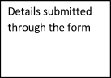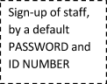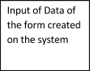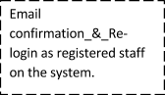



**Figure 1. Staff keeping process.**

**2.0.0 Student Case Files Data Storage ;( Information Gathering process)**

The process of gathering data and information about Student case file records, will be a system where we the project team will have an interview with the Director record keeping unit of AUN Security department, in order to understand how their case records are filed. Also after the detailed process is related to us, we will keep notes of these details to enable us design and implement this part of the system functionality.

**2.1.0 Student Case Files Data Storage ;( Implementation process)**

The implementation of the case file record keeping, will involve us designing a form on the system that will to hold, keep and store data of cases which will be inputted on the system by a staff or security personnel. This process will involve the security personnel to login and add a case file, by clicking icon and a form will be displayed for entering the record and saved on the system. This case record can be viewed, and as well modified incase of any omissions while imputing of this record and stored for future use as deemed fit by the security department.

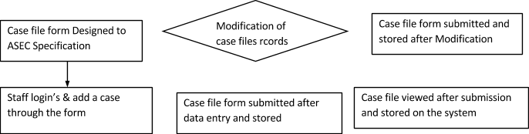

**Figure 2. Case Files Record keeping process**

**3.0.0 Staff Schedule ;( Information Gathering process)**

This process involves we the project team been updated and sent their detailed document of how the staff scheduling process is done for staff allocation with regards to days, locations, shifts of morning, afternoon and night subsequently. Therefore after this document is sent to us, we will communicate a review of it to the Head HR Personnel and ask for more inputs as deemed fit, through emails and interview sections.

**3.1.0 Staff Schedule ;( Implementation process)**

The implementation process for the scheduling, will involve us the project team creating sets of tables, comprising of locations, shifts, days, staffs which is already existing. Therefore is to link all linkable tables on the database for this purpose. Furthermore, after these tables and links are effectively done, then we will design and algorithm that will automatically create the schedule for each week in allocating shifts and Staffs appropriately.

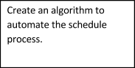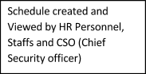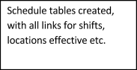

**Figure 3. Schedule Implementation Process.**

**4.0.0 Staff Employment ;( Information Gathering process)**

Staff employment information gathering will be basically done, by getting detailed information from the HR Chief on how their prospective staff details are gotten and what other detail is taken manually. This will enable us understand the recruitment process better for implementation.

**4.1.0 Staff Employment ;( Implementation process)**

The implementation for recruitment will be us creating a portal for opening and closing after registration process. The opening portal will involve enabling prospective staffs fill out the details needed on a form, which is created on the system for recruitment. Furthermore the closing of the portal will enable the HR department or Personnel close recruitment process on the system. These accessibilities will be designed by us the project team as a link on the system for the external users and open/close portal for the internal HR personnel.

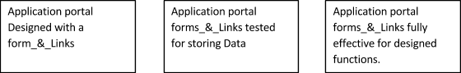

Figure 4, Recruitment Implementation Process.

**5.0.0 Visitor Data Storage ;( Information Gathering process)**

It is however important to note at this time, that keeping and gathering of visitors information will be in two phases as outlined below.

**5.1.0 Phase 1. External Visitors;**

This group termed as external visitors. The gathering of information will involve getting direction and input from the security department on how they want or wish to keep record and store such information for their use.

**5.1.1 Phase 2. Internal Visitors;**

Also following the gathering of information for the internal visitors, cited here as the **“female student visitors”** to boys dorms in the university. The process of gathering this information, will be gotten from the AUN Security department sending us a detailed document of how this information are stored manually and also we as a team will occasionally meet them for more clarifications etc.

**5.1.2 Visitors Data Storage ;( Implementation process)**

This process will involves us creating a function on the system that will comprise of the internal visitors and external visitor’s data been stored through input of form data collection and submitted on the system for storage. This process is to create accessibility of visitor’s information promptly.

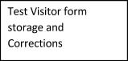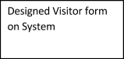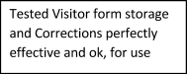

**Figure 5. Visitor Information Storage Implementation process.**

**6.0.0 Validation ;( Information Gathering process)**

This process will be a series of information sent to us the project team from the security team on how they, carry out daily validation of cabs, students, staffs and any external visitors.

**6.1.0 Validation ;( Implementation process)**

The validation design will be a process or will involve where the visitor or person’s been validated will have to input his unique number and the design will validate to check if the record exist on the system or not. However if it doesn’t exist, it will prompt no search, while if it exist on the database of the system, the whole details will prompt up.

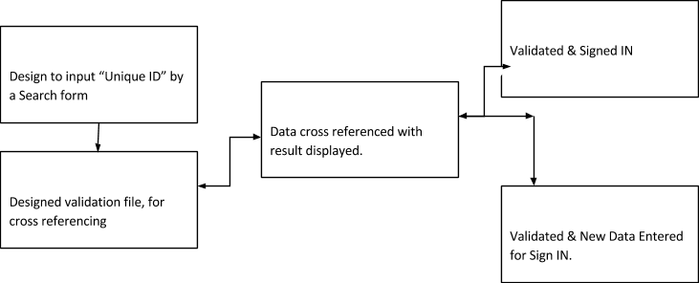

Figure 6. Validation Implementation Process

**7.0.0 OUTPUT SUMMARY.**

The Final output product after the process of Deploying ASEC will, yield more effectiveness and efficiency in validation processes, record keeping of staff records, case files, recruitment data, visitor access and validation will be delivered during the specified time of project completion as defined in the project charter, system functional document, project management plan and any other supporting document for the project.